**Members:**

* Syed Hamza Ali (16k-4059)
* Okesh Kumar (16k-4026)
* Usama Sheikh (16k-4063)
* Anas Bin Faisal (16k-4064)
* Saad Ismail (16k-4060)

**Abstract:**

OnAir, as the name suggests, is a personalized news broadcasting network encompasses

areas from all over Pakistan. Generally, remote and rural areas that often are neglected by the public and the authorities due to various reasons, in which one of the reason is the

unavailability of first-hand knowledge. Our proposed network overcomes this problem by

bridging the gap among people. This system comprises of a highly responsive user-

friendly mobile application and a web portal. In the mobile application, at first, a user is

requested to invite other people, especially, from areas which are not yet covered by our

reporters. This will be done by showcasing the user’s contact list, where the user can select

its contacts and send them an invite to join our network. This is how we will expand our

coverage and recruit reporters in our network, this phenomenon is also termed as ‘snowball

effect’.

A user, who is now part of our reporting team, can see other reporters with their areas and

can request them for first-hand knowledge of their area. Upon request of user ‘U’ regarding

area ‘A’, all the shared information from reporters on area ‘A’ will be shown to the user ‘U’.

This request can be to inquire about hospitals, schools, and availability of other utilities in

that area, in context of the same city, the inquiry can be about traffic situations or to report

on an incident that had been taken place recently, etc. All the data is stored in databases (S3/Firebase/MongoDB). On a web application, there is an admin portal where insights of all the information exchange that had been taken place on mobile app in a day are available along with their location information respectively. This information can be used to deliver insights to respective authorities and to derive public attention to high priority events.

**Introduction:**

Purpose: The purpose of this document is to give an intensive description of our proposed project ‘onAir’. It will help in explaining the purpose and features of the system, the interfaces of the system, what the system will do, the conditions under which it must operate and how the system will react with end users.

Intended Audience and Reading Suggestions: Although our intended audience includes supervisor, team members, and end-users but our main focus is on the end-users.

Project Scope: onAir can be implemented everywhere, where problems exist. It would be a more efficient way for end-users to make their queries resolve without any hustle and everyone would prefer this system over the traditional complaining system.

**Main Features:**

1. Once a user installs the app using the apk link, the user is asked to invite some of the contacts from his contact list using SMS service. This phenomenon is popularly known as the snowball effect.
2. The contact number of the invited user is stored in our database, this helps the coming user register against the number already stored in our system.
3. Seamless OAuth2 Authentication through Google Accounts and Phone Number using Firebase Authentication.
4. The registered users then have the option to post questions related to their queries based on their GeoSpatial Location.
5. As the question is posted on our portal, a message is broadcasted to a specific audience residing under 1 KM radius. This will help to reduce the clutter in users’ timeline.
6. The broadcast message is sent as a notification to the user of this specific radius and the portal asks whether or not the user can be of any help. User can post their suggestions and answer regarding that query. In addition to it, the user can also post pictures that might be of any help to the other user. These pictures are then stored in S3 Database.
7. In addition to all these features, there is an admin portal that can monitor all the user insights.

**Technology Used:**

* Node.JS
* Flutter
* MongoDB
* Amazon Simple Storage Service (AWS S3)
* Amazon Elastic Compute Cloud (AWS EC2)
* Firebase Authentication
* Firebase Cloud Messaging
* OpenStreetMap (MapBox)

**Functional Requirements:**

1. User needs to register to the system through the app.
2. Once the user is registered, he has to log in.
3. After the user is logged in he/she can send an invitation link to 10 people from his/her contact list.
4. User can ask questions about any particular area.
5. User can give a response to a question if he lies at the parameter of that question i.e. within 1 KM range.
6. User can give response using text and image.

**Nonfunctional Requirements:**

1. The project must be easily accessible and fast to the end-user.
2. The interface must be user-friendly and easy to use so that the user doesn’t have any confusion or difficulty using the system.
3. The use of bots must be eliminated and great care will be taken to ensure that the personal details of the users are not compromised in any way. A two-factor authentication system can be utilized to ensure that the login security of users is protected and no malicious attack will be made successful.
4. The system must not be vulnerable to any known issues and other security bugs like SQL injection, XSS etc.
5. Moreover, homogenization must be done in order to add clarity and consistency to our models and ensuring that all the stakeholders clearly follow the process and can check that their requirements are being followed.

**Weaknesses:**

1. The application’s network is not SSH certified and that is, the data is in the unencrypted form which is a security concern.

**Design and Implementation Constraints:**

1. Software Constraints: The system is an application designed for Android users, i.e. users with other operating systems cannot have access to it.
2. Cultural Constraints: The system is in the English language. Also, it would require a great amount of time to build the trust of local people from the society.
3. Legal Constraints: User data will be protected and will not be shared to any third party without the user’s concern and permission.

**Database Schema:**

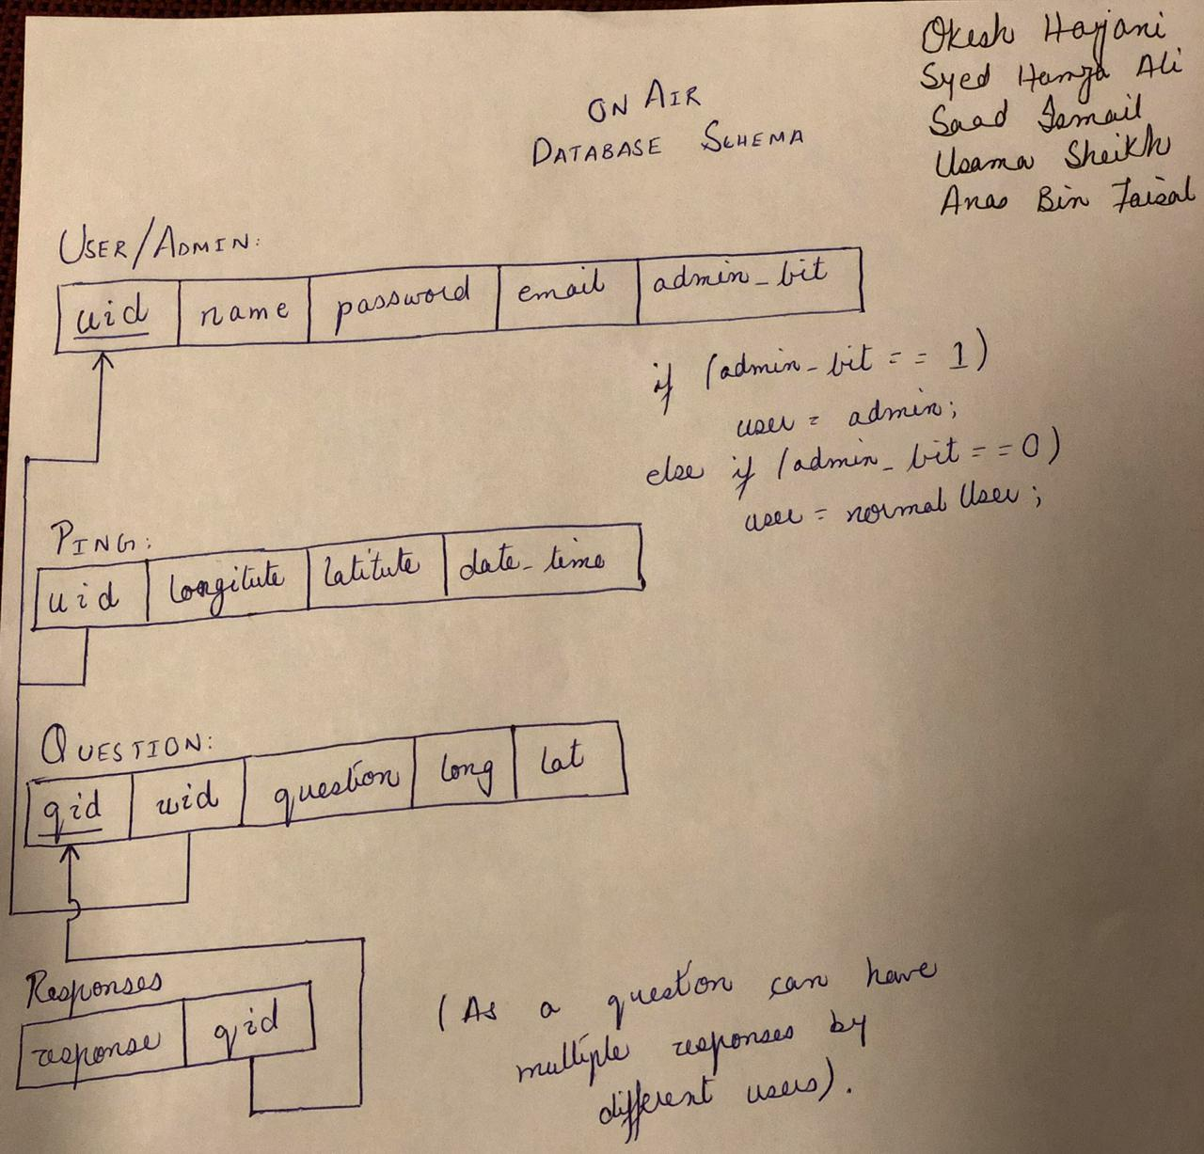

**Future Work:**

1. All the functionality that is currently available on app can also be made available on web portal. This will enable people to post queries just by opening their web browsers.
2. As we currently have developed an application for Android users, another app can be developed for iOS and Windows users as well.
3. Use of Google Recaptcha can help us eliminate bots from the system by ensuring that the user is a human being.
4. A voice bot can be developed to assist the end-users post their queries in the future using speech. This can be done using speech-to-text and text-to-speech APIs which in the background uses Modern NLP and NER techniques to revolutionize the whole process.
5. We would also try to integrate our system with government official services like Water and Sewerage Board, Electric Companies, Police, and other important services.
6. A recommendation system can be developed that will help us in improving our services based on the recommendations/suggestions given by the end-users.